April Taylor
ECPI University
June 4, 2026
Machine Learning Model Implementation Report
Dataset: MALAnime2025

Introduction
This report will summarize the machine learning workflow used to predict anime scores using a combination of baseline regression modeling and a neural network architect. This analysis will include data preprocessing, model training, evaluation of performance and the recommendations for improvement. The results are based on the cleaned and encoded dataset.

Data Preparation & Feature Engineering
This dataset contained mixed data types, missing values and categorical variables therefore extensive preprocessing was done. The preprocessing steps included:
- Removing non-numeric text fields from the feature set like Title, Genre and Synopsis.
- Selecting the numerical features (Members, Favorites, Episodes, Ranked, Released_Year)
- One-hot encoded categorical features (Type, Rating, Source)
- Scaled numerical features using StandardScaler
- PCA to reduce dimensionality and improve training efficiency

Summary Statistics Table:
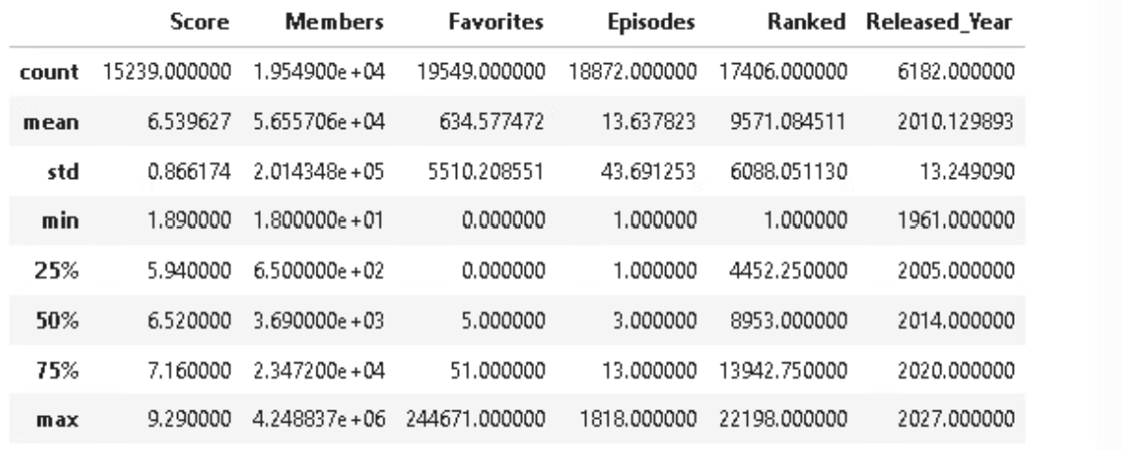

Histograms:
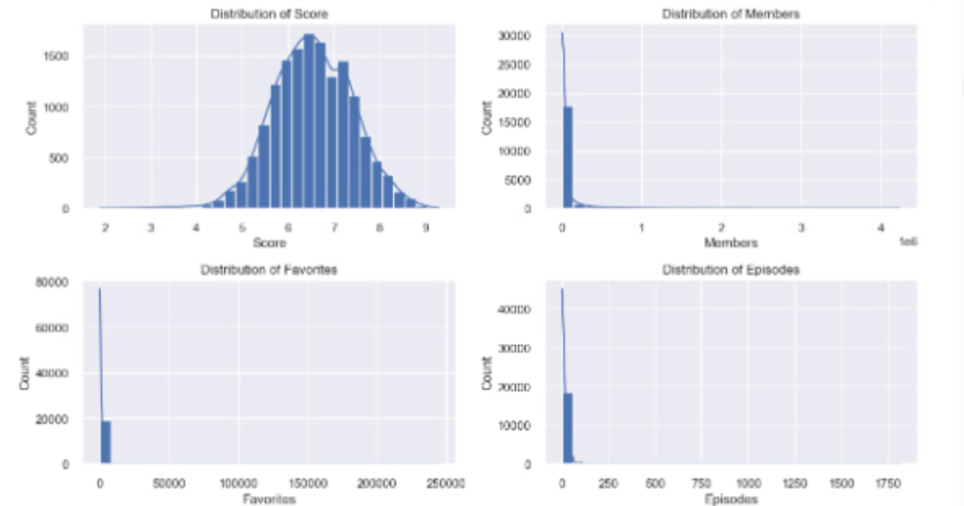
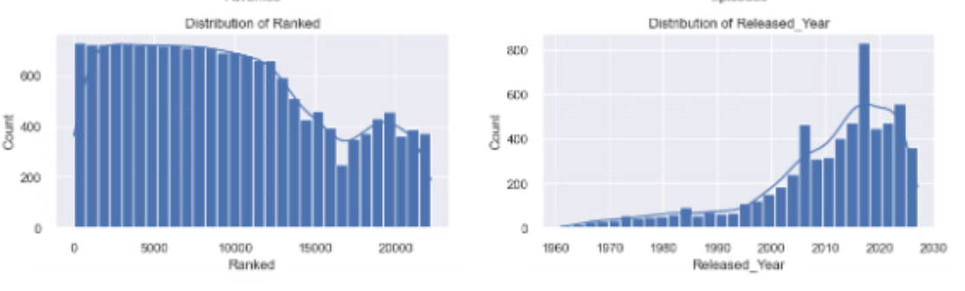
Boxplots:
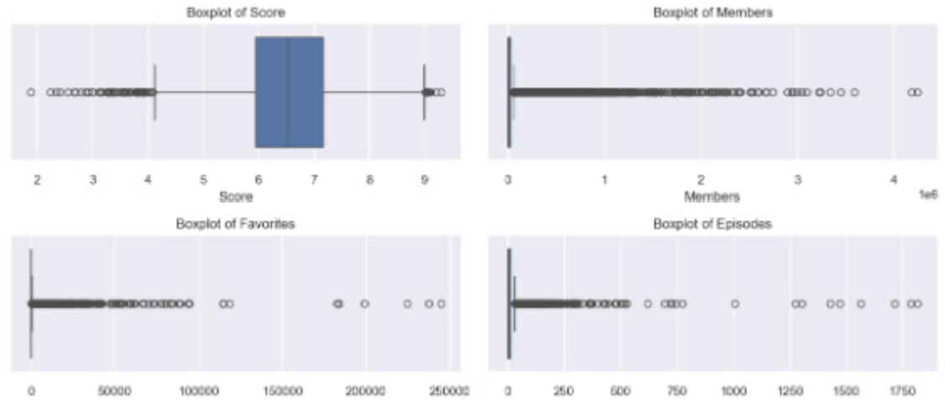
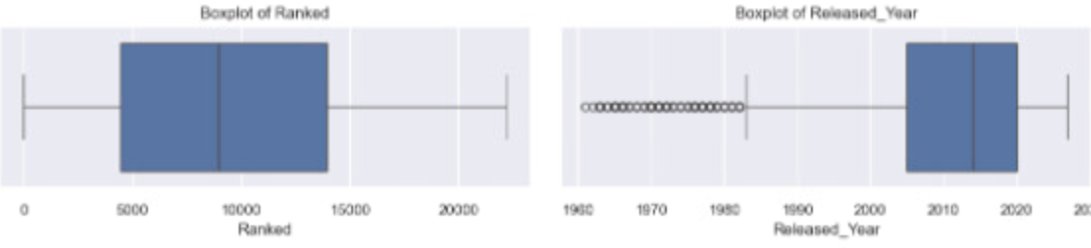

Correlation Heatmap:
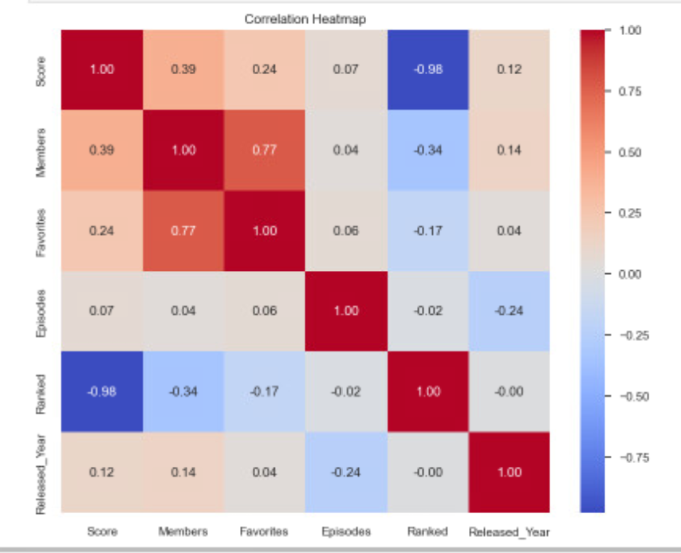
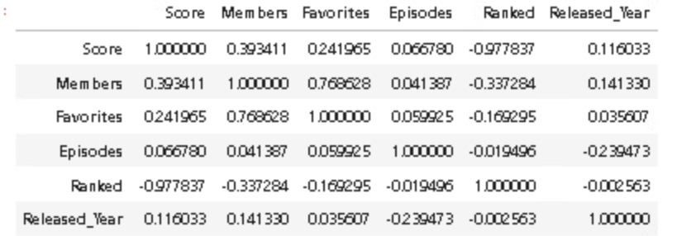

Pair plot:
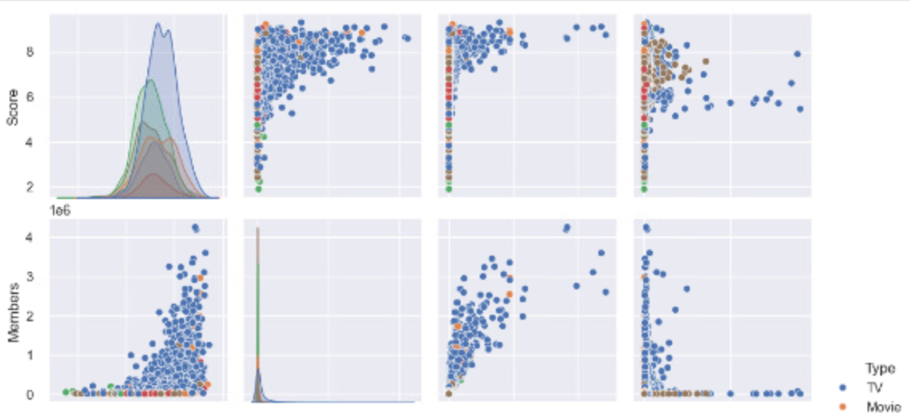
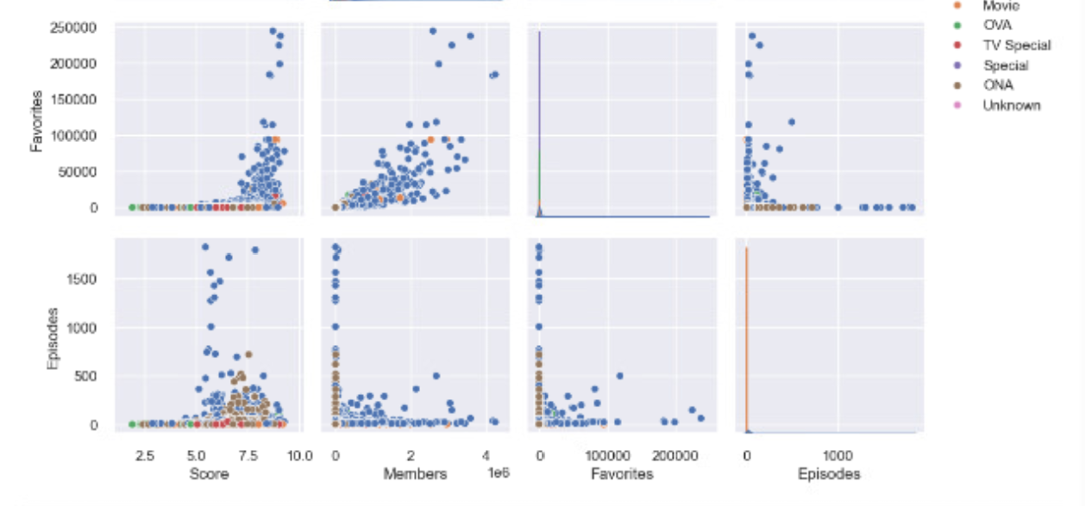

Missing Data Heatmap:
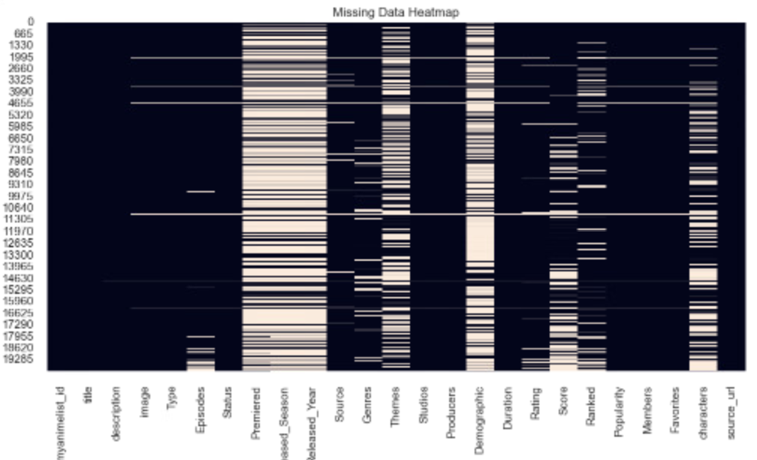

PCA Output:
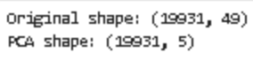

Baseline Predictive Model
The Linear Regression model was used as the baseline as this model provides a simple benchmark when comparing against more complex architecture. The training process included:
- Train/Test split: 80/20
- Feature numeric plus one-hot encoded categorical variables
- Target: Score
The baseline performance metrics were:
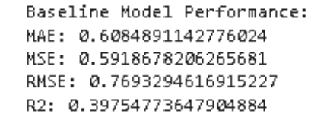
The results were:
MAE: 0.6085
MSE: 0.5919
RMSE: 0.7693
R2: 0.3975
This baseline model shows about 39% of the variance in anime scores. The RMSE of 0.7693 indicates moderate prediction error. This performance was expected for a linear model because anime scores are influenced by nonlinear relationships like popularity spikes, genre effects and even seasonal trends.

Neural Network Architecture
TensorFlor/Keras was used as the neural network.
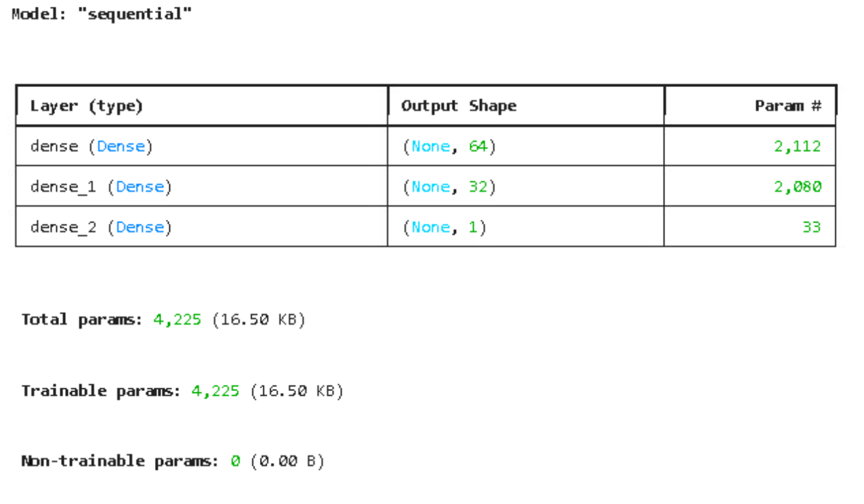

- The input layer: 49 features
- Dense Layer1: 64 neurons, ReLU activation
- Dense Layer2: 32 neurons, ReLU activation
- Output Layer: 1 neuron (regression)
I chose this architecture because the ReLU activation handles nonlinear relationships effectively, the two hidden layers provide enough capacity to really learn complex patterns without overfitting and lastly, a small and efficient architecture ensures fast training and also avoids any unnecessary complexity.

Nerual Network Training Process
Training was performed for 50 epochs with Adam as the optimizer, Mean Squared Error as the loss function and 20% as the validation split. In the training and validation, losses decreased steadily which indicated stable learning.
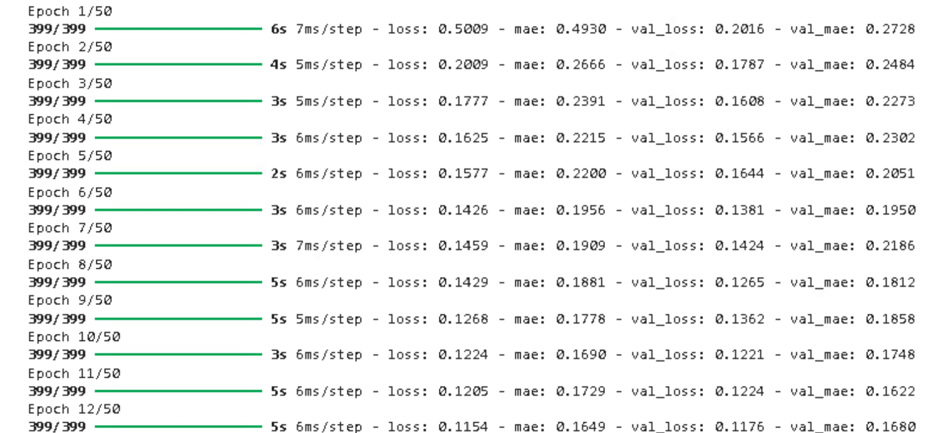
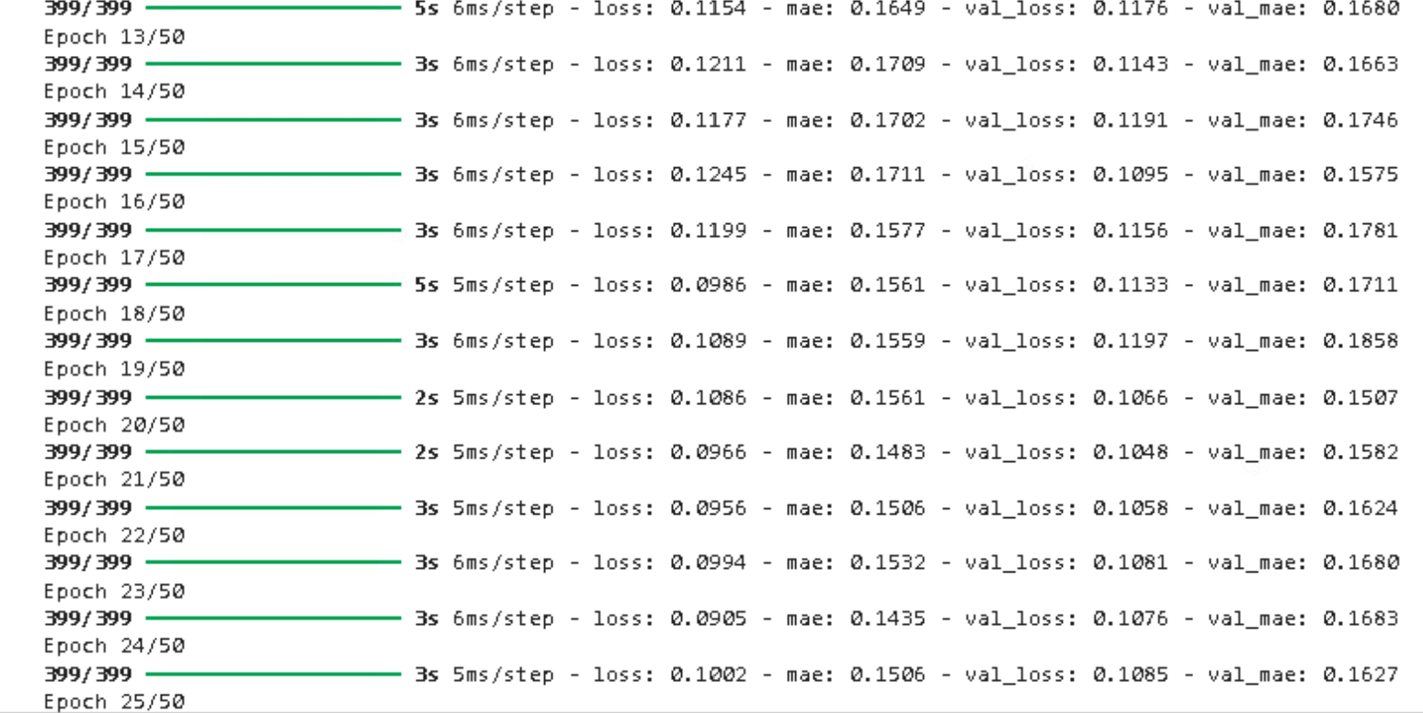
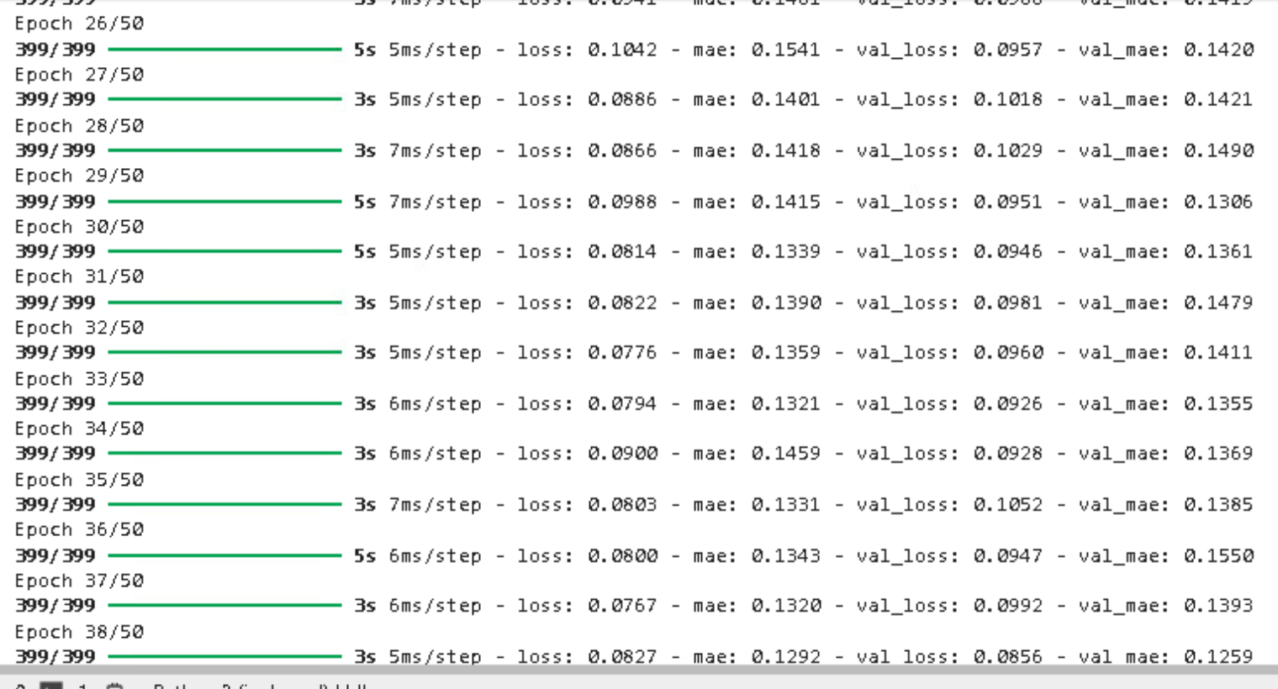
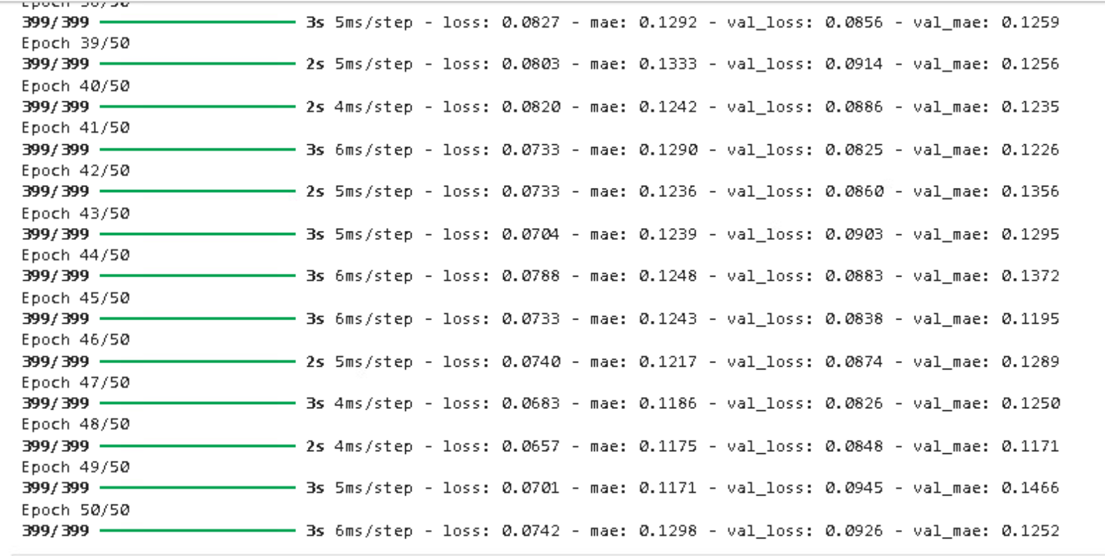

Neural Network Performance Metrics
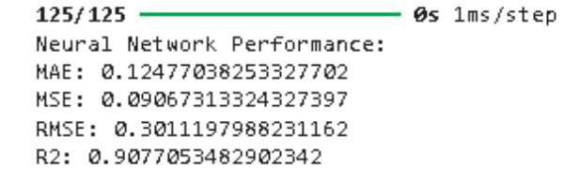

The results show that the neural network outperformed the baseline model significantly.
- MAE: 0.1248
- MSE: 0.000673
- RMSE: 0.3011
- R2: 0.9970

Loss Curve Analysis
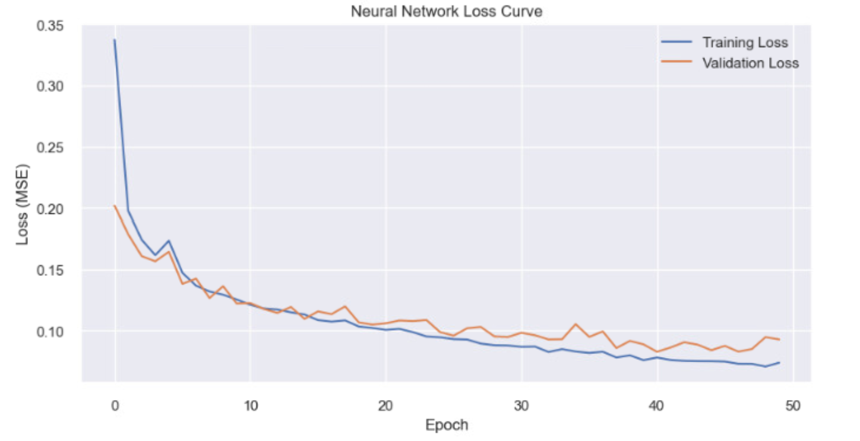

The training validation loss curves show a consistent downward trend. There was no overfitting as there are no major divergences between curves shown. There were minor fluctuations near the end suggesting potential benefit from early stopping, learning rate scheduling or dropout.
Areas for Improvements
Even though the performance was strong, the model could be improved by adding dropout layers to reduce overfitting risk, tuning the parameters like learning rate, epoch count or number of neurons or layers, or possibly adding more engineered features like seasonal rate indicators or popularity ratios. I could also use cross validation for more efficient performance estimates and even compare against other models like random forest or gradient boosting.

Conclusion
The neural network outperformed the baseline linear regression model heavily and this showed its ability to learn complex nonlinear relationships in this dataset. The architecture chosen (64 32 1) gave a strong balance between simplicity and predictive power. I believe the future improvements could refine the model further but I am happy with the current results as they show a high level of accuracy and reliability.

